# Cellular protein extraction

## Materials Needed

* Refrigerated centrifuge
* Tube rotator or orbital shaker
* Vortex mixer
* Pipettes
* Pipet-aid
* 10-1000 µL
* Ice, or freezer microtube rack
* Microcentrifuge tubes
* Cold PBS
* Lysis buffer
* Protease and phosphatase inhibitors (Pierce 87785)
* Cell lifters (Corning 3008)
* Disruption of genomic DNA
* Sonicator (Branson digital sonifier)
* Micrococcal nuclease (ThermoFisher 88216)

## Prep

|  |  |  |  |  |
| --- | --- | --- | --- | --- |
| Lysis buffer amounts (from ThermoFisher M-PER protocol) | | | | |
|  |  | **Area (cm2)** | **PBS rinse (mL)** | **Lysis buffer (mL)** |
| **Dishes** | 60 mm | 21 | 3 | 0.25-0.5 |
| 100 mm | 55 | 5 | 0.5-1 |
| 150 mm | 152 | 10 | 1-2 |
| **Flasks** | T-25 | 25 | 3 | 0.25-0.5 |
| T-75 | 75 | 5 | 0.5-1 |
| T-160 | 162 | 10 | 1-2 |
| **Plates** | 6 well | 9 | 0.2-0.4 | 0.2-0.4 |
| 24 well | 4 | 0.1- 0.2 | 0.1- 0.2 |
| 96 well | 2 | 0.05-0.1 | 0.05-0.1 |

1. Turn on centrifuge and set to 4°C.
2. Add protease inhibitor to lysis buffer (1:50 or more depending on lysis method, see below)
3. Put a 600 mL beaker filled with ice under the hood, then put the 50 mL tubes for cell suspension in the ice.

## Procedure

1. Aspirate medium, rinse cells 1-2x with ice-cold PBS, and aspirate into waste container. **PBS for cell harvest can be shared among cell lines.** Cross-contamination is not an issue because the cells will be lysed and will not be subcultured.
2. Add lysis buffer with protease inhibitors to dish. Scrape cells, aspirate, add to tube and vortex.
   1. Buffer volume can be adjusted to achieve desired [protein]. **Base [protease inhibitor] on biological sample quantity, not buffer volume.** When combining dishes of cells, more protease inhibitor should be used because cellular protein will be highly concentrated. I have generally found that 20 μL protease inhibitor in 1 mL lysis buffer per 15 cm dish of cells is adequate.
   2. Combine multiple dishes of cells for higher [protein]: scrape two 15 cm dishes of cells in 5 mL ice cold PBS combine in 15 mL tube, centrifuge 1500 rpm 5 min 4°C to pellet cells, remove supernatant, resuspend in 1 mL lysis buffer with protease inhibitors, vortex, and sonicate.
   3. Cells can be lysed in 1x SDS-PAGE sample buffer, but protein quantification is more difficult.
3. Disruption of genomic DNA:
   1. **Sonication:** Sonication is useful for detecting membrane- and chromatin-bound proteins. See [CST](http://www.cellsignal.com/common/content/content.jsp?id=western) Western blotting protocol and “Guide to Successful Western Blotting.”
      1. Branson digital sonifier: put sonication sign up on cold room door and put on ear protection. We have cold suits for extended periods of time in the cold room. Use arrow keys to navigate settings, and dial on side to adjust amplitude.
      2. Fill a beaker with ice for tube being sonicated, and keep the remaining tubes on ice.
      3. **Sonicate on ice for 5-10 seconds at 40% power. If this is not effective, use 3 5-10 second pulses at 35-40% power, with 10 seconds between pulses. Lysate may foam if sonicator tip is not fully submerged.**
      4. Clean with diH2O after each sample. Do not turn off machine after use.
   2. **Micrococcal nuclease:** Add 3 μL nuclease and 5 μL 100 mM CaCl2 to 106-107 cells (150 mm dish), vortex, and incubate 37°C 5 min. Amounts from ThermoFisher 78840 fractionation kit.
   3. Vortex, tube rotator 5-30 min 4°C, centrifuge 5 min 10-15,000 x g 4°C
4. Quantify with BCA assay.

# Tissue protein extraction

## Materials Needed

* Refrigerated centrifuge
* Tube rotator or orbital shaker
* Vortex mixer
* QIAGEN TissueLyser II bead homogenizer
* Pipettes, 10-1000 µL and 300 µL multichannel
* Ice, or freezer microtube rack
* Forceps
* 0.5 mL, 1.5 mL or 2 mL centrifuge tubes
* Lysis buffer
* Protease Inhibitor Cocktail (Pierce 87786)

## Prep

1. Turn on centrifuge and set to 4°C.
2. Add protease inhibitor to lysis buffer (1:100-1:50)

## Procedure

1. **Remove tissues from freezer, weigh out 0.1 g tissue** in a weigh boat and record. Note that this is merely a good practice and not important. You will normalize to total protein, not to tissue weight.
2. **Place tissues in tubes with TissueLyser beads (1-2 beads/tube).**
3. **Homogenize with TissueLyser.**
4. **Leave on tube rotator 30-45 min 4°C.**
5. **Centrifuge samples** 10 min 10,000 x *g* 4°C.
6. **Pipette supernatant into fresh 1.5 mL tubes.** Wipe pipette tip with a kimwipe to avoid getting lipid in the supernatant you collect. Do not disturb the pellet at the bottom.
7. **Centrifuge supernatant** 5 min 10,000 x *g* 4°C.
8. **Aliquot supernatant** into labeled tubes.
   1. BCA assay requires 10 or 25 μL
   2. Gel requires 16 μL
9. **Freeze aliquots at -80°C.**
10. Clean up.

# BCA total protein quantification

## Materials Needed

* Pipettes
  + 0.1-10 μL
  + 10-100 μL
  + 10-1000 µL
  + 300 µL multichannel
* Refrigerated centrifuge
* Ice, or freezer microtube rack
* Heat block
* Fume hood
* Pierce BCA Protein Assay Kit (Pierce 23225)
* Microplates (Pierce 15041, Costar 3370 or 9017)
* Plate Reader

## Prep

1. Prepare standard curve
   1. Dilute the contents of one albumin standard (BSA) ampule into several clean vials with di-H2O, or preferably using the same diluent as the sample(s). Each 1 mL ampule of 2 mg/mL albumin standard is sufficient to prepare a set of diluted standards with three replicates.
   2. Standard curve dilutions can be made in advance and stored at 4°C.

|  |  |  |  |
| --- | --- | --- | --- |
| **Table 1.** Preparation of Diluted Albumin (BSA) Standards | | | |
| Dilution Scheme for Microplate Procedure (Working Range = 20-2,000µg/mL) | | | |
|  | **Diluent (µL)** | **BSA stock (µL)** | **Final [BSA] (µg/mL)** |
| A | 0 | 50 of Stock | 2000 |
| **B** | **150** | **450 of Stock** | **1500** |
| **C** | **500** | **500 of Stock** | **1000** |
| **D** | **200** | **200 of vial B dilution** | **750** |
| **E** | **500** | **500 of vial C dilution** | **500** |
| **F** | **500** | **500 of vial E dilution** | **250** |
| **G** | **500** | **500 of vial F dilution** | **125** |
| H | 800 | 200 of vial G dilution | 25 |
| **I** | **500** | **0** | **0 = Blank** |
| Dilution Scheme for Enhanced Test Tube Protocol (Working Range = 5–250µg/mL) | | | |
|  | **Diluent (µL)** | **BSA stock (µL)** | **Final [BSA] (µg/mL)** |
| A | 700 | 100 of Stock | 250 |
| B | 400 | 400 of vial A dilution | 125 |
| C | 450 | 300 of vial B dilution | 50 |
| D | 400 | 400 of vial C dilution | 25 |
| E | 400 | 100 of vial D dilution | 5 |
| F | 400 | 0 | 0 = Blank |

## Procedure

1. Prepare BCA working reagent (WR) by mixing 50 parts BCA Reagent A with 1 part BCA Reagent B
   1. 200 μL WR per sample for microplate procedure, 2.0 mL WR per sample for test-tube procedure
   2. 10 mL (9800 uL A, 200 uL B) for half plate (48 wells), 20 mL for 96 wells
   3. Note: When Reagent B is first added to Reagent A, turbidity is observed that quickly disappears upon mixing to yield a clear, green WR. WR is stable for several days at room temperature (RT).
   4. Pipette standards into the microplate in duplicate.
      1. 10 μL (working range 125-2000 µg/mL) or 25 μL (working range 20-2000 μg/mL).
2. Dilute samples 1:5 and pipette into microplate in duplicate. Use the same volumes as for standards (10 or 25 μL).
   1. Sample and diluent can be added separately to the wells, instead of making dilutions in separate tubes. Diluent can be added to wells first with multichannel pipette, followed by samples, or the other way around, whichever is preferred. For example, add 20 μL di-H2O to all sample wells, and then 5 μL of each sample.
3. Add WR to 200 μL with multichannel pipette and cover plate with adhesive plate seal.
   1. If 10 μL sample was used, add 190 μL WR. If 25 μL sample was used, add 175 μL WR.
4. Mix plate thoroughly on the DPC micromix 5 plate shaker for 30 seconds.
5. Incubate 20-30 min 37°C or 2 hours RT (working range 20-2000 μg/mL)
   1. We use the Seahorse plate incubator for this.
   2. For enhanced sensitivity, incubate 30 min 60°C (working range 5-250 μg/mL)
6. Read plate at 562 nm
   1. Place plate in the tray of the Molecular Devices SpectraMax MX system.
   2. Open SoftMax Pro, Protocols > Protein Quant > BCA or Brendon > BCA. Click read.
   3. Note: We also have a SpectraMax Paradigm system with SoftMax Pro 6.4.1. SoftMax licenses only allow one computer, so the program cannot be installed on a personal computer. We have one laptop with both SoftMax 5 and 6, and one with just SoftMax 5.

## Data analysis

1. SoftMax Pro
   1. It is easiest to set up a template in SoftMax Pro. If creating new groups on the plate template (for a set of samples, for example), the data reduction steps will not always be retained. This can be resolved by copying columns (containing formulas for the samples) from a group with data reduction steps. Highlight the columns of interest, right click, copy columns, paste.
   2. Export all plates and groups as a .txt file (plate data: both raw and reduced, output format: plate). Excel reads the .xls files as corrupted.
2. Excel
3. Export raw plate data as a .txt file, and open in Excel.
4. Subtract blank from absorbance values of standard.
5. Plot a standard curve with concentration (x) vs. absorbance (y) and ≥4 points.
6. Use the standard curve equation to interpolate the samples and find their concentrations.
7. Make a table listing the sample IDs, absorbance values, and protein concentrations.
8. Calculate the sample dilution factor: [desired]/[measured]. Use the same units for each.
9. Input the desired total volume for each sample (such as 1500 μL).
10. Calculate the lysate volume required: desired total volume*sample dilution factor
11. Calculate the dilution buffer volume required: desired total volume-lysate volume

## Adjust samples

1. Add lysis buffer to adjust samples to the same total protein concentration.
   1. I usually adjust to 2 mg/mL and then add 4X sample buffer for a [final]=1.5 mg/mL.
   2. I tend to over-adjust lysates. To prevent this, add slightly more sample than required.

## Notes

* **Samples can optionally be run again after adjustment, though it is usually not necessary.**
* **When measured after adjustment, samples should be within ~10% of the target adjusted value. There is no official standard for this.**
* **Pierce only provides enough BSA ampules for 10 assays, but the other reagents will likely last much longer. If more standard is needed, purchase additional 2 mg/mL BSA (23210).**
* **It’s best to run all samples in the same assay to eliminate inter-assay variability.**
* **Store all components of the BCA kit at RT.**
* **Note that the Costar 9017 microplates have medium protein binding capacity. Protein binding is not desired for BCA, but should not affect results in the short time proteins are in the plate.**
* The BCA assay is preferred over the Bradford assay because it is compatible with detergents. The Sigma RIPA buffer contains 1% NP-40, 0.1% SDS, and 0.5% deoxycholate. The Bradford assay is only compatible with 0.25% NP-40, 0.025% SDS, and 0.2% deoxycholate, but the BCA assay works with up to 5% of each of these detergents. Diluting samples 1:5 before the Bradford assay helps reduce interference from RIPA buffer detergents, but the BCA assay is more reliable in this situation.
* The Bio-Rad RC-DC assay or the Pierce 660 nm protein assay reagent (22660) with ionic detergent compatibility reagent (22663) can be used if total protein quantification is desired after addition of SDS-PAGE loading buffer.
* **Notes from Pierce BCA assay kit instructions**
* Wavelengths from 540-590 nm have been used successfully with this method.
* Because plate readers use a shorter light path length than cuvette spectrophotometers, the Microplate Procedure requires a greater sample to WR ratio to obtain the same sensitivity as the standard Test Tube Procedure. Increase incubation to 2 hrs. for higher 562nm readings
* Increasing the incubation time or ratio of sample volume to WR increases the net 562nm measurement for each well and lowers both the minimum detection level of the reagent and the working range of the assay.

# RC-DC total protein quantification

1. Add 5 μL of DC Reagent S to each 250 μL of DC Reagent A that will be needed for the run. This solution is referred to as **Reagent A ́**. Each standard or sample assayed will require 127 μL of Reagent A ́.
   1. Reagent A ́ is stable for one week even though precipitate will form after one day. If precipitate forms, warm the solution and vortex. Do not pipet the undissolved precipitate as this will likely plug the tip of the pipet and alter the volume of Reagent A ́ added to the sample.
2. Prepare 3-5 dilutions of a protein standard from 0.2 mg/ml to 1.5 mg/ml protein. A standard curve should be prepared each time the assay is performed. For best results, the standards should always be prepared in the same buffer as the sample.
3. Pipet 5 μL of standards and samples into clean, dry microfuge tubes.
4. Add 25 μL *RC* reagent I into each tube and vortex. Incubate the tubes 1 min RT.
5. Add 25 μL *RC* reagent II into each tube and vortex. Centrifuge the tubes 15,000 x g 3–5 min.
   1. If pellet is not solid enough, increase centrifuge time to 10 min.
6. Discard the supernatant by inverting the tubes on clean, absorbent tissue paper. Allow the liquid to drain completely from the tubes.
7. Add 25 μL reagent A ́ to each microfuge tube and vortex. Incubate tubes 5 min RT, or until precipitate is completely dissolved. Vortex again before proceeding to next step.
8. Add 250 μL *DC* reagent B to each tube and vortex immediately. Incubate 15 min RT.
9. Add 100 μL from each tube to a plate in duplicate and read absorbance at 650-750 nm.
   1. The absorbance will be stable for at least 1 hr.
   2. Multiply all volumes by 5 for the standard microtube assay.

# Electrophoresis prep

## Materials Needed

* Life Technologies NuPAGE gels
  + NuPAGE 4-12% Bis-Tris gels, 1.5 mm, 15 well (NP0336BOX)
  + NuPAGE 20x MOPS SDS buffer (NP0001)
  + NuPAGE antioxidant (NP0005)
  + NuPAGE LDS sample buffer (NP0007)
  + NuPAGE reducing agent (DTT, NP0009)
* Tris-glycine gels
  + Bio-Rad Mini-Protean TGX Gels
  + Bio-Rad 10x Tris Glycine SDS, 5L (161-0772)
* Laemmli Buffer 4X (Bio-Rad 161-0747)
* 2-Mercaptoethanol (2ME)
  + Sigma, >99%/14.3 M (M6250)
  + Bio-Rad, >98%/14.2 M (161-0710)
* Electrophoresis cell
  + Life Technologies XCell SureLock mini-cell (EI0001)
  + Bio-Rad Mini-Protean Tetra Cell (165-8000)
* Power Supply for electrophoresis and transfer cells
  + Bio-Rad PowerPac HC (164-5052)
* Gel opening lever and gel lifter
* Set of pipettes, 10-1000 µL with tips
* Gel loading pipette tips (Cole-Parmer EW-25713-12)
* Molecular Weight Marker
  + Bio-Rad Precision Plus WesternC Standard with Strep-tactin HRP conjugate (161-0385)
  + Bio-Rad Precision Plus Dual Color (161-0374)
  + Thermo Scientific PageRuler

## Reagent prep

1. **Running buffer**
   1. **NuPAGE MOPS SDS running buffer**
      1. 100 mL 20x NuPAGE MOPS SDS running buffer, 1900 mL di-H2O, 2 g sodium bisulfite (1 g/L).
      2. Dissolve sodium bisulfite in 10 mL di-H2O, then add to buffer.
      3. Store at RT. Each mini cell run requires 6-800 mL. Each midi cell run requires 1 L.
   2. **TGS running buffer**
      1. 200 mL 10x Tris Glycine SDS, 1800 mL di-H2O
      2. 25 mM Tris, 192 mM Glycine, 0.1% SDS, pH 8.3.
      3. Store at RT. Each run requires 800 mL.
2. **Transfer buffer**
   1. Bio-Rad Criterion 1.5-2 L, Bio-Rad mini trans-blot or NuPAGE XCell II 0.5-1L, semi-dry 0.2 L
   2. **Add MeOH last under a fume hood**.
   3. **NuPAGE transfer buffer**
      1. 100 mL 20x NuPAGE transfer buffer, 400 mL MeOH, 1500 mL di-H2O
      2. Use 1x with 20% MeOH for wet transfer of NuPAGE Bis-Tris gels.
      3. Use 2x with 10% MeOH for semi-dry transfer of NuPAGE Bis-Tris gels to improve efficiency.
   4. **Tris-glycine-MeOH transfer buffer**
      1. 200 mL 10x Tris Glycine, 400 mL MeOH, 1400 mL di-H2O.
      2. Makes 25 mM Tris, 192 mM Glycine, 20% v/v MeOH, pH 8.3. Store at 4°C.
3. **Wash Buffer – 1L**
   1. 100 mL 10x Wash Buffer, 900 mL di-H2O. Store at 4°C.
4. **0.1 M NaOH (0.1 N)**
   1. Dilute 100 mL 1N NaOH in 900 mL di-H2O. Add H2O first, then NaOH. Store at RT.

## Advance prep

1. Design gels and blots: plan samples, controls, and proteins of interest.
2. Reserve time on imager.
3. **Cut membranes and filter paper**
   1. **Mini gels: 8x8 cm, midi gels: 8x13 cm**
   2. **Filter paper cutting strategy:** each sheet of the VWR 703 blotting paper is 46x57 cm, which will fit 5 8 cm sheets on the 46 cm side and 4 13 cm sheets on the 57 cm side. Fold over twice, so the sheet is now 13 cm wide. Cut with paper cutter every 8 cm. This leaves you with 8x13 cm stacks 4 sheets thick.

## Sample prep

1. Thaw samples on ice. Total protein concentration should have been determined.
2. **Turn on heat block and set to 95°C.**
3. **Make 4x sample buffer in fume hood**
   1. Add 10% reducing agent (2ME or DTT) to 4X NuPAGE LDS or Laemmli sample buffer (10 μL 2ME per 90 μL buffer) before each use. Final 1X 2.5% [2ME] 355 mM or [DTT] 50 mM.
   2. 2ME and DTT are interchangeable.
   3. **Protease inhibitors are not necessary in 4x sample buffer if already added to lysates.**
   4. 4X Laemmli Sample Buffer formulation:
      1. 277.8 mM Tris-HCl, pH 6.8, 4.4% LDS, 44.4% (w/v) glycerol, 0.02% bromophenol blue
4. **Add 1 part 4x sample buffer to 3 parts sample.** This does not need to be done under the hood.
5. **Vortex samples for 15 sec.** Vortex 4 tubes at once to expedite.
6. **Centrifuge samples** ≥3000 x *g* RT 1 min
7. **Heat Samples in a heat block.**
   1. NuPAGE LDS: **10 min 70°C**
   2. Laemmli: **5 min 95°C**
   3. This step reduces disulfide bonds and denatures proteins.
   4. Can also boil water on a hot plate, then turn off heat and float samples in a foam rack.
   5. If tubes are heated for ≥5 min or >95°C the lids may pop open.
   6. You can also punch a hole in the tube caps with a needle to let steam escape.
   7. **MWM does not need to be heated.**
   8. Leave tubes at RT for a few minutes so the steam is pulled down during centrifugation.
   9. **Sample buffer can be added ahead of time, but samples should be heated just before use.**
   10. **For re-use of reduced samples, heat again.**
   11. **Life Technologies does not recommend storing reduced samples.** **Reoxidation of samples can occur during storage and produce inconsistent results. They recommend reducing ≤1 hour before each run. See NuPAGE technical guide p.13.**
8. **Centrifuge samples** ≥3000 x *g* RT 1 min

# Gel electrophoresis

## Prep

### Life Technologies XCell SureLock mini cell

1. **1 mm gels hold less sample, but transfer more easily than 1.5 mm.**
2. If running multiple gels, number each gel. Number gel lanes (lane 1 on left of tall plate).
3. Rinse gels with di-H2O. Handle gel by the edges only.
4. **IMPORTANT:** Peel off the tape covering the slot on the back of the gel cassette.
5. Slowly pull the comb out of the cassette. Removing too quickly can tear the wells.
6. Use a pipette to gently wash the wells with 1X running buffer. Invert the gel and shake to remove buffer. Repeat twice. Fill the wells with running buffer, displacing all air bubbles.
7. **Double check buffer cores to make sure wires and banana plugs are intact.**
8. Lower the Buffer Core into the Lower Buffer Chamber so that the negative electrode fits into the opening in the gold plate on the Lower Buffer Chamber as shown in the figure.
9. 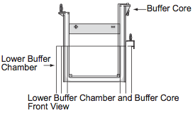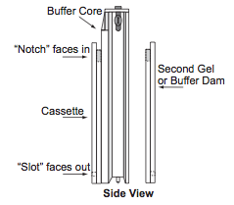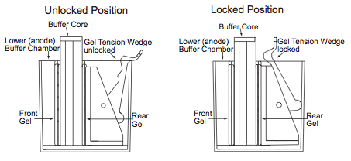Insert gel cassettes into the lower buffer chamber. Place one cassette behind the core and one cassette in front of the core. For each cassette, the shorter “well” side of the cassette faces in towards the buffer core. The slot on the back of the cassette must face out towards the lower buffer chamber. If you are running only one gel, replace the rear gel cassette with the Buffer Dam.
10. Insert the Gel Tension Wedge into the XCell *SureLock* behind the buffer core in its unlocked position. Pull forward on the Gel Tension Lever until it comes to a firm stop and gels or gel/buffer dam are snug against the buffer core.
11. Fill the upper buffer chamber (in between the gels)with 175 mL 1x MOPS SDS Running Buffer with NuPAGE antioxidant or sodium bisulfite. Buffer should cover wells. Check for leaks.
12. **DO NOT FILL THE LOWER BUFFER CHAMBER UNTIL AFTER LOADING SAMPLES.** It will be much easier to load the gels, especially the gel toward the front of the cell. Lanes and pipette tips are difficult to see through the buffer.

### Life Technologies XCell SureLock midi cell

1. **1 mm gels hold less sample, but transfer more easily than 1.5 mm.**
2. If running multiple gels, number each gel. Number gel lanes (lane 1 on left of tall plate).
3. Rinse gels with di-H2O. Handle gel by edges only.
4. **IMPORTANT:** Peel off the tape covering the slot on the back of the gel cassette.
5. Slowly pull the comb out of the cassette. Removing too quickly can tear the wells.
6. Use a pipette to gently fill wells with running buffer, displacing air bubbles. Repeat twice.
7. Assemble buffer cores
   1. Place one gel on either side of the two buffer cores. Insert buffer cores into the lower buffer chamber. Place one cassette behind the core and one cassette in front of the core. For each cassette, the shorter “well” side of the cassette faces in towards the buffer core. The slot on the back of the cassette must face out towards the lower buffer chamber.
   2. 4 gels: two gels on both buffer cores.
   3. 3 gels: two gels on first buffer core, gel and displacement dam on second buffer core.
   4. 2 gels: two gels on first buffer core, displacement dam instead of second buffer core.
   5. 1 gel: gel and buffer dam on first buffer core, displacement dam instead of second buffer core.
8. While holding the assembly together with your hands, insert the Buffer Cores with the gel cassettes into the Lower Buffer Chamber such that the negative electrode fits into the opening in the gold plate on the Lower Buffer Chamber. Always hold the cassette assembly by its edges as shown in the following figure.
9. Lock the gel tension wedge to seal the buffer cores in place.

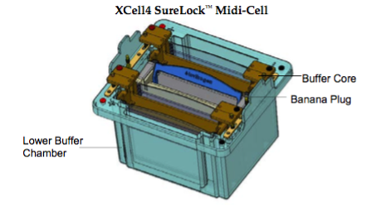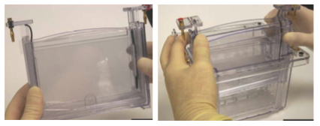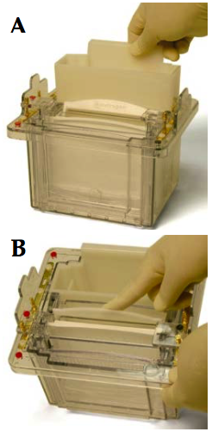

**Above: midi cell overview.**

**Middle: recommendation for handling buffer core.**

**Right: gel and buffer dam**

**A and B: Two gels and displacement dam.**

From XCell4 SureLock Midi-Cell User Guide

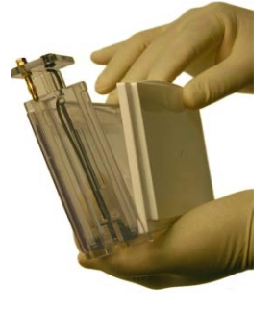

1. Fill the upper buffer chamber (in between the gels)with 400 mL 1x MOPS SDS Running Buffer with NuPAGE antioxidant or sodium bisulfite. Buffer should cover wells. Check for leaks.
2. Do not add buffer to the displacement dam.
3. **DO NOT FILL THE LOWER BUFFER CHAMBER UNTIL AFTER LOADING SAMPLES.** It will be easier to load the gels. Lanes and pipette tips are difficult to see through the buffer.

### Bio-Rad Mini-Protean system

1. Remove a Bio-Rad TGX gel from the storage pouch.
2. Remove the comb at the top by positioning your thumbs on the ridges on each end of the comb and pushing upward with a smooth, continuous motion.
3. **Remove the tape at the bottom of the cassette. THIS IS IMPORTANT! IF YOU DO NOT REMOVE THE TAPE, THE ELECTROPHORESIS CELL WILL NOT RUN.**
4. Rinse out the wells with Running Buffer using a pipette.
5. **Assemble the apparatus** (see figure)
   1. Take out the Electrode Assembly Module. Open the green clamps (**figure 2a**).
   2. **Place the first gel onto the gel supports** (the little white crossbars on the bottom of the Electrode Assembly Module with the half-circle bumps on the fronts), short plate inward. Allow the gel to rest at a 30° angle, tilting away from the center of the Module (**figure 2b**).
   3. **Place the second gel onto the gel supports.**
      1. Use the Buffer Dam when running only one gel (clear plastic square that serves as a divider). Make sure the writing faces the green gaskets at the center of the Module.
      2. Only use the second module when running 3-4 gels.
6. Pull gels toward center and slide green clamps over them **simultaneously** to lock (**figure 2c**).
   1. The module can leak if both clamps are not closed at the same time.
7. **Place the Module(s) into the tank** (**figure 2f**).
   1. If only running one or two gels, do not place the second module in the tank. Place the Electrode Assembly Module (the one with the banana plugs) in the back position of the tank. Make sure that the black/ negative electrode is on the left with the black strip in the tank and the red electrode is on the right matching the red strip in the tank.
   2. If loading samples is difficult, you can leave the Module out of the tank while loading. If you do this, **PICK UP THE MODULES BY THE WHITE BRACKETS ON THE TOP! DO NOT grab by the gel plates in the middle.** This squeezes the gels together and samples will shoot out of the wells.
8. **Fill the chamber in between the two gels** (or one gel and buffer dam) with Running Buffer to just under the edge of the outer gel plate.
9. **Fill the tank** with Running Buffer to appropriate the mark on the front of the tank.
   1. The “blotting” mark is for using the mini trans-blot module with the tetra-cell tank for transfer.

**Figures from Bio-Rad Mini Protean TGX gels instruction manual.**



## Sample loading

1. **ENSURE TAPE HAS BEEN REMOVED FROM BOTTOM OF GEL.**
2. **Add 5 μL molecular weight marker to lane 1 (on the left if looking through the tall plate).**
   1. Gels can curve so it is best not to have samples in the outside lanes.
   2. Optional: Add 20 µL sample buffer to last lane as a blank.
3. **Load samples**

|  |  |  |  |
| --- | --- | --- | --- |
| **Gel** | **Wells** | **Thickness (mm)** | **Well capacity (μL)** |
| Bio-Rad Mini-Protean TGX | 10 | 1 | 25 |
| Bio-Rad Mini-Protean TGX | 15 | 1 | 15 |
| Life Technologies NuPAGE Novex Bis-Tris | 10 | 1 | 25 |
| Life Technologies NuPAGE Novex Bis-Tris | 10 | 1.5 | 37 |
| Life Technologies NuPAGE Novex Bis-Tris | 15 | 1 | 15 |
| Life Technologies NuPAGE Novex Bis-Tris | 15 | 1.5 | 25 |
| Life Technologies NuPAGE Novex Bis-Tris | 20 | 1 | 25 |

* 1. Pipette samples the same way for each well. Dispense sample slowly and allow to settle in well.Only dispense to first stop. Do not puncture the well. Shift tubes up or over in rack after loading to keep track. For best results, load sample buffer in empty wells.
  2. Use 10 or 200 μL tips. Gel loading tips can be difficult to use. Sorenson barrier tips are too thick. Lower chair and elevate electrophoresis cell to make loading easier.
  3. Load 10-50 μg total protein, 10-100 ng purified protein.
  4. **1 mm gels hold less sample, but transfer more easily than 1.5 mm.**

1. **Fill the lower buffer chamber with 1x MOPS SDS running buffer after loading samples.**
   1. XCell mini cell: 600 mL
   2. XCell4 midi cell: 1 gel 540 mL, 2 gels 560 mL, 3 gels 680 mL, 4 gels 700 mL
2. **Secure the lid on top of the tank.** Make sure the lid is firmly in place and the clear plastic tabs on either side (next to the banana plugs) are sticking up.

## Electrophoresis

1. Insert the electrical leads into the power supply. Check that they are securely inserted.
2. Set power supply.
   1. **NuPAGE XCell SureLock system: 150 V 75 min or 110 V for longer**
   2. Bio-Rad Mini-Protean Tetra Cell with tris-glycine gels: 200 V 20-35 min
   3. Hand-cast gels: 70V 15 min until dye front passes stacking gel, then 90V to bottom of gel.
   4. Ice can be helpful because the buffer will get hot.
3. Start power supply. **Stop electrophoresis when the dye front reaches bottom of gel.**
4. **Refrigerate or freeze samples in case you need to re-run them.**
5. **Remove Gels**
   1. After electrophoresis run is complete, turn off power supply and disconnect electrical leads.
   2. Discard running buffer from the modules. You can save and re-use buffer from the tank with the Mini-Protean system. This is not possible with the XCell SureLock system because the upper buffer chamber will leak as soon as you release the gel tension wedge.
   3. Break open gel cassettes with gel opening lever. Remove tall plate, and leave gels on short plates. If gels remain on tall plate, carefully separate with a gel lifter and place on short plate.
   4. Cut off the wells and bottom end of the gel while it is on the short plate.
   5. Notch top right of gel (above last well) for orientation.
   6. Clean the electrophoresis modules and tank with di-H2O.

## Protein standards

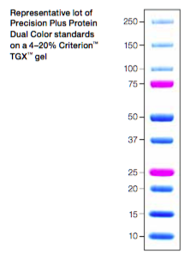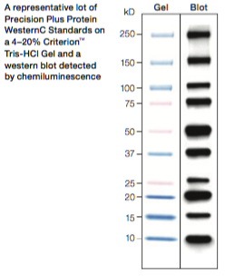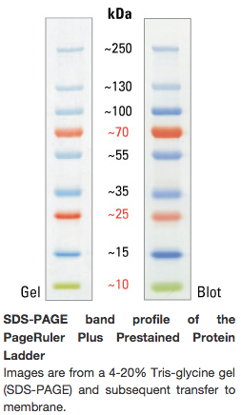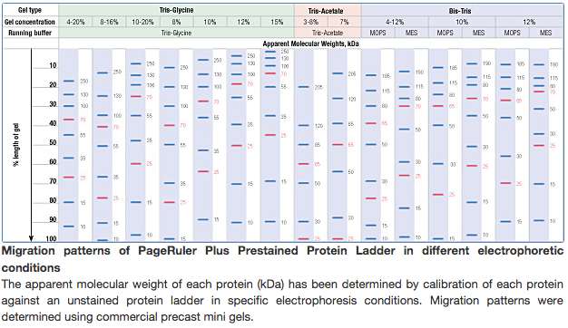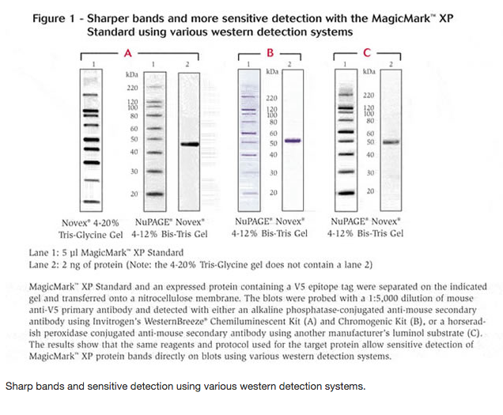

# Membrane transfer

## Materials Needed

* Transfer Cell
  + ThermoFisher XCell II blot module (EI9051)
  + Pierce fast semi-dry blotter (88217)
  + Bio-Rad PowerPac adapter (164-5064)
  + Bio-Rad TransBlot SD semi-dry cell (170-3940)
  + CBS double-wide blotter (EBU-402)
* Power supply for transfer cell
* Transfer Buffer
  + NuPAGE gels
  + NuPAGE transfer buffer (NP0006)
  + Pierce MeOH-free transfer buffer (35045)
  + Tris glycine gels
  + Pierce MeOH-free transfer buffer (35045)
  + 10x tris glycine (Bio-Rad 161-0771)
  + Methanol (Fisher A456-4)
* Membrane and blot paper
* RPI Mini Blot Container, Black, 15.4X10.4X2.5H cm, pack of 6 (248718B)
* Total protein stain
  + Ponceau S (Sigma P7170)
  + Thermo Pierce Reversible Protein Stain Kit for PVDF Membranes (24585)
* 0.1M NaOH (Sigma S2567)
* Fisherbrand Bent, Smooth Offset-Tipped forceps for handling membranes (Fisher 10-295)
* Razor blade for cutting membrane
* Solvent-proof permanent marker (VWR)

## General transfer prep

1. **Chill transfer buffer to 4-10°C.** Use 1x NuPAGE or Tris-Glycine transfer buffer with 20% MeOH. NuPAGE transfer buffer will maintain the neutral pH environment. Transfer conditions may differ for NuPAGE vs. Tris-Glycine buffer.
2. **Cut membranes and filter paper as described above.**
3. **Do not equilibrate NuPAGE gels before wet transfer.** Equilibrate Tris-Glycine gels 10 min.
4. **Membranes**
   1. Notch top right for orientation
   2. **Label top right corner with solvent-proof permanent marker.**
   3. Nitrocellulose does not require equilibration, simply wet with transfer buffer. PVDF: Immerse in 100% MeOH, then equilibrate in transfer buffer 10 min on orbital shaker (with MeOH for NuPAGE).
5. Wet blotting filter paper with transfer buffer.
6. Soak sponge pads in transfer buffer. Squeeze pads or smooth with gel lifter to remove air.

## Wet transfer

### Bio-Rad criterion blotter

1. Pour **4°C Transfer Buffer** into each compartment of the assembly tray. Each run requires 1.5-2 L.
2. Place membranes in small front compartment. Allow to soak. **Always use forceps for membrane.**
3. Set the blot module in the back compartment of the assembly tray, black side down, red side up.
4. Soak foam pads and filter paper in transfer buffer.
5. **Double check blot modules and transfer cell to make sure wires and banana plugs are intact.**
6. Fill the Criterion tank ½ full with Transfer Buffer.
7. Place **ice block** and a **stir bar** in the tank. There should be a lever to keep the ice block in place.
8. Assemble the cassettes. **Prep 1 cassette at a time. Do not move membrane once it is on gel.** Each side should have 4-8 sheets thin blot paper. Eight sheets provide a tighter fit, but it is more difficult to fasten the clasp on the blot module. Use the roller to smooth out air bubbles after placing the gel, then after placing the membrane, and finally after placing the 2nd piece of filter paper.
9. Lock the cassettes together and add to the tank. Red side faces logo on front. If only running one gel, leave the second blot module out of the tank. **The key to avoiding air bubbles is to fasten the cassette clasp while completely submerged in transfer buffer.**

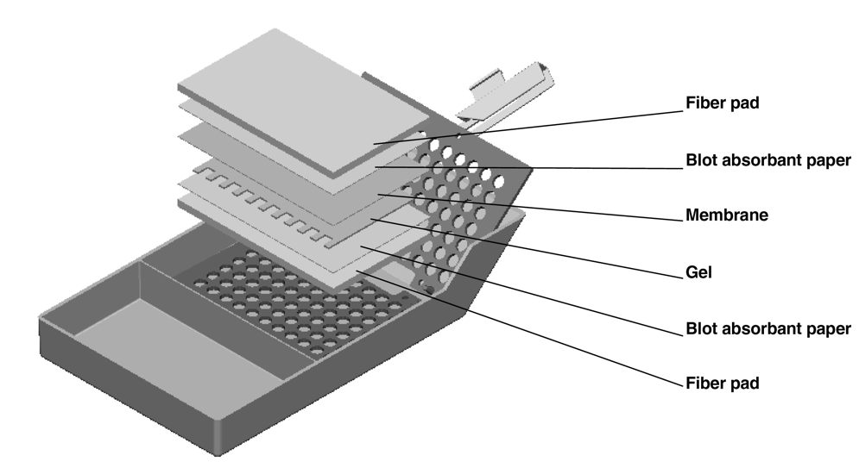

Bio-Rad criterion blotter

Completed blot module

**Red**

Sponge pad

4-8x blot paper

**Membrane**

Gel

4-8x blot paper

Sponge pad

**Black**

1. Add Transfer Buffer to fill line.
2. Place tank on stir plate.
3. **Run transfer:** 1-2 hours 90-100 V, 12-18 hours 30 V (90 mA) 4°C.

### Bio-Rad mini trans-blot cell

1. Equilibrate membrane, blotting pads, and filter paper as above.
2. **Double check blot modules and transfer cell to make sure wires and banana plugs are intact.**
3. Assemble cassettes and add to blot module as above. **The key to avoiding air bubbles is to fasten the cassette clasp while completely submerged in transfer buffer.**
4. **Run transfer:** 1-2 hours 100 V, 12-18 hours 30 V (90 mA) 4°C.

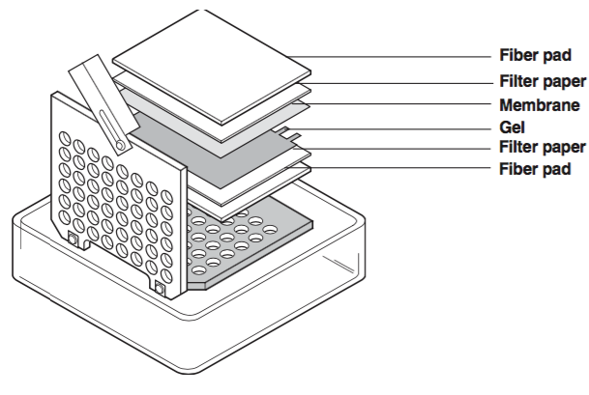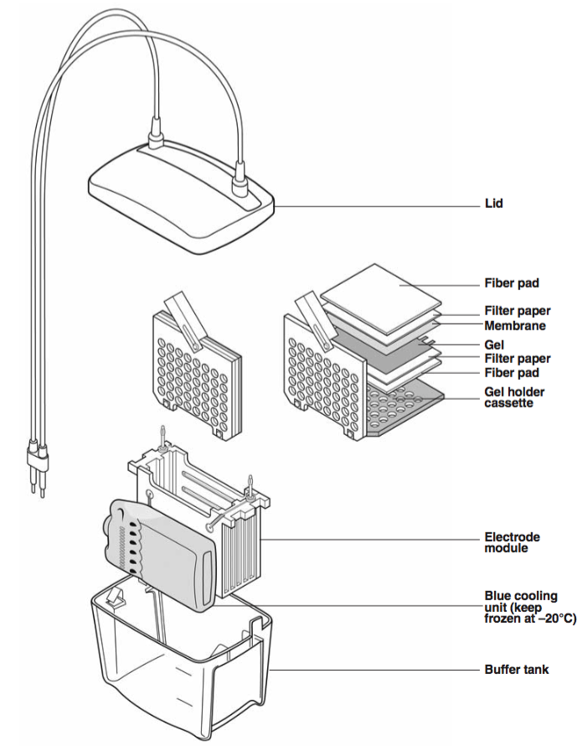

### NuPAGE XCell II blot module

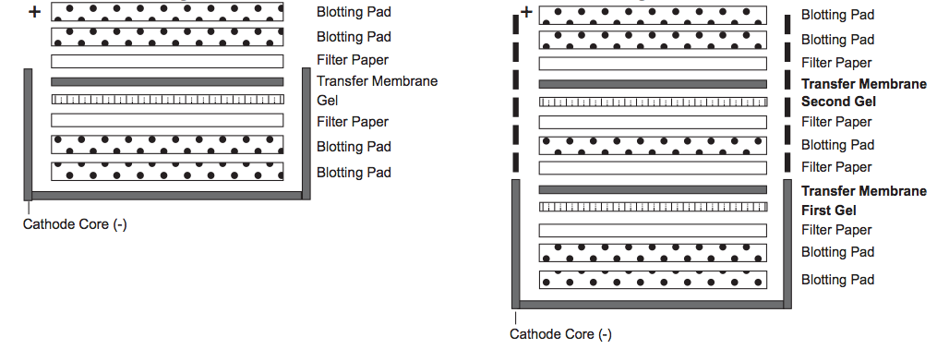

**One gel**

**Two gels**

From NuPAGE technical guide and XCell II blot module manual

1. Add two blotting pads to the cathode core.
2. Wet the gel with transfer buffer.
3. Put a piece of pre-soaked extra thick blot paper on top of the gel, flip over, and carefully separate from the short plate with a gel lifter. Well 1 should currently be on the right.
4. Place the gel and filter paper in the cathode core, and roll out air bubbles.
5. Carefully set membrane on top of gel, and roll out air bubbles.
6. Add filter paper and blotting pads on top. Completed assembly should rise 0.5 cm above the side of the cathode core. A second gel assembly can be added, but I have experienced consistently incomplete transfer of the second gel.
7. Firmly attach the anode and place in tank. There should be 1 cm between the top of the gel assembly and the top of the inner chamber of the blot module.
8. **Insert gel tension wedge and lock into place. The gel short plate can also be used as a spacer in front of the blot module in the tank so it seals well.**
9. Fill blot module with 1X NuPAGE Transfer Buffer until the gel assembly is covered. **Transfer buffer should not leak out of the blot module.** To avoid generating extra conductivity and heat, do not fill the chamber all the way to the top.
10. Fill the Lower Buffer Chamber with 650 mL di-H2O to dissipate heat produced during the run. The water level should reach approximately 2 cm from the top of the Lower Buffer Chamber.
11. Place the lid on the unit and insert the electrical leads into the power supply.
12. **Run transfer 60 min 30 V RT.**

### CBS midi blotter

1. Equilibrate membrane, blotting pads, and filter paper as above.

CBS midi blotter

Completed gel cassette

**Red**

Sponge pad

4-8x blot paper

**Membrane**

Gel

4-8x blot paper

Sponge pad

**Black**

**Red**

1. Assemble gel cassettes as shown. Each cassette can hold two mini gels or one midi gel. Current goes from black to red.
2. **Plug the hose inlets with a loop of rubber tubing if not using circulation.** This blotter is equipped with coolant circulating capability. Connect a recirculating water bath or pump with a flow rate of 500 mL/min or 15 psi. Note that the pump setup makes this blotter complicated to use.
3. **Run transfer**: 1-2 hours 100 V, 18 hours 26 V 250-300 mA 4°C

## Semi-dry transfer

### Pierce fast semi-dry blotter

1. **Assemble gel cassettes in the semi dry transfer cell. Prep 1 cassette at a time.** 
   1. The semi-dry transfer cells can accommodate ≤4 mini gels. However, I have had issues when transferring >1 gel in the Pierce semi-dry blotter, especially when using their MeOH-free transfer buffer. Transfer efficiency for PVDF is much better when MeOH is included.
   2. **Put a piece of pre-soaked blot paper on the anode.**
   3. **Add the membrane on top of the blot paper.** Roll out bubbles. Well 1 will be on the left.
   4. **Put a piece of pre-soaked extra thick blot paper on top of the gel, flip over, and carefully separate from the short plate with a gel lifter. Well 1 should currently be on the right.**
   5. **Carefully set the gel on top of the membrane using the second piece of blot paper to guide. Well 1 will now be on the left. Lift blot paper off gel and roll out air bubbles.**

Thermo semi-dry

Completed gel cassette

**Cathode (top)**

Blot Paper

Gel

**Membrane**

Blot Paper

**Anode (bottom)**

* 1. Current goes from Cathode (top) to anode (bottom), so gel is above membrane.

1. Position the four push lock mechanisms on the bottom plate in the up (open) position (Figure 2). **Align the push locks on one side, then gently lower cathode to the other side** and simultaneously press down the right and left side handles to snap the unit closed (Figure 3). The locking mechanisms of all four push locks should be fully closed and in the down position (Figure 4).

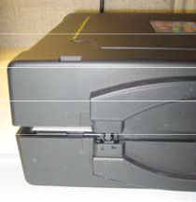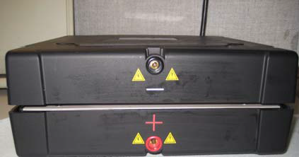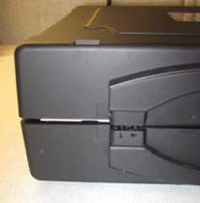

Figure 2. Open locks.

Figure 3. Align the top and bottom to lock unit.

Figure 4. Closed locks.

1. **Set the power supply and start transfer.**
   1. Run 7-10 min 25 V if using Pierce MeOH-free transfer buffer.
   2. Run 30-60 min 15 V if using Tris-Glycine-MeOH or 2x NuPAGE transfer buffer.
   3. Semi-dry blotters operate at a lower voltage than wet blotters, so heating is not an issue.
   4. Thicker gels or larger proteins will require longer transfer.

### Bio-Rad TransBlot SD

Bio-Rad semi-dry

Completed gel sandwich

**Cathode (top)**

Filter Paper

Gel

**Membrane**

Filter Paper

**Anode (bottom)**

1. Equilibrate materials as above.
2. Assemble gel sandwich as shown.
3. Transfer 15 V 30 min. Large gels can be transferred ≤60 min ≤25 V. Current runs from cathode (top) to anode (bottom)

When transfer is finished, turn off power supply and disconnect transfer cell from power supply. **Open transfer cassettes and remove membranes. You now have membranes.** Throw out the gels. If you are not going to be proceeding to the Detection step right away, you can refrigerate membranes in Transfer Buffer in a sealed container.

# Total protein stain

**Determine transfer efficiency with a total protein stain.** A prestained protein ladder can be used to check transfer efficiency, but good ladder transfer does not equal good lysate transfer.

1. **Ponceau S**
   1. Ponceau S works best with nitrocellulose, but can still be used with PVDF.
   2. **Immerse membrane in Ponceau S solution (Sigma P7170) for 5 min.**
   3. You can save and re-use the Ponceau solution. Aliquot into 50 mL tube for re-use.
   4. **Destain 3x1 min with 10 mL di-H2O on shaker (in the same blot box).**
      1. Do not pour di-H2O directly on membrane.
      2. Only use 10 mL each time. **Too much will wash off the stain.**
   5. Place membrane in sheet protector, smooth out air bubbles with roller, and image (see **Image Capture**).
   6. **Cut off excess membrane** above or below ends of the MWM. DO NOT CUT OFF SIDES. **If performing separate incubations, cut membrane into strips while in sheet protector.** Notch top right corner again and label top right corner again with solvent-proof permanent marker.
   7. Remove blot from sheet protector and place in tray for washing.
   8. Erase stain with 20 mL 0.1 M NaOH 30 sec
   9. Wash briefly in 20 mL di-H2O.
2. **Thermo Pierce reversible protein stain**
   1. This stain is expensive and difficult to remove from membranes. Ponceau S preferred.
   2. Reagent prep: mix destain and eraser solutions 1:1 with MeOH.
   3. Stain
      1. Rinse membrane in di-H2O
      2. Add sensitizer to membrane in blot box for 2 min on shaker. Decant solution.
      3. Add reversible stain to membrane for 1 min on shaker. Decant.
   4. Destain
      1. Add Destain:MeOH solution to membrane 5 min on shaker. Decant into waste container.
      2. Rinse membrane 5x with di-H2O.
   5. Image membrane with white light and white tray.
   6. Erase stain
      1. Add Eraser:MeOH solution to membrane 10 min on shaker. Decant into waste container.
   7. Rinse membrane 5x with di-H2O.

# Western blotting

## Materials Needed

* Pierce Fast Western Kit, SuperSignal West Dura
  + Mouse primary ABs (Pierce 35070)
  + Rabbit primary ABs (Pierce 35071)
* Standard reagents
  + Blocking
    - 5% non-fat dry milk in TBST
    - 3% BSA in TBS
    - Pierce Super Block in PBS (37515)
* Antibody Diluent
  + 5% w/v BSA, 1X TBS, 0.1% Tween-20
  + Pierce Super Block in PBST (37516)
* Pierce Restore Plus stripping buffer
* Molecular weight marker
  + Bio-Rad Precision Plus WesternC with Strep-tactin HRP (161-0385)
  + Bio-Rad Precision Plus Dual Color (161-0374)
  + ThermoFisher PageRuler
* Antibodies and proteins
* Containers for incubating membranes
  + RPI Blot Boxes
    - RPI Strip Blot Container, Clear, 3x10x2.5H cm, pack of 2 (248778)
    - RPI Mini Blot Container, Black, 11.5x8.9x2.2H cm, pack of 6 (248717B)
    - RPI Mini Blot Container, Black, 15.4X10.4X2.5H cm, pack of 6 (248718B)
  + Alternatives
    - Li-Cor Biosciences Western Incubation Boxes
    - Fisher 10x15” autoclave bags (01-826-4)
    - TEW Impulse Sealer (# TISH-300)
* Bent, smooth offset-tipped forceps for membranes (Fisher)
* Rocker
* Imaging system
* Office Depot standard weight clear sheet protectors
* Solvent-proof permanent marker (VWR)

## Reagent prep

1. **Set out Western blot reagents:**
   1. **Wash Buffer (100 mL/blot in 50 mL tubes or bottle)**
   2. **Fast Western Antibody (AB) Diluent (10 mL/blot for primary AB, 9 mL/blot for secondary in 15 mL tubes)**
      1. Shake the AB Diluent well before use. It is a saturated solution and settling may occur.
      2. Set out exactly what you need because the kit only contains 200 mL.
2. **Primary AB solutions**
   1. Mix in 15 mL conical tubes**.**
   2. **Shake the AB Diluent well before use.** It is a saturated solution and settling may occur.
3. **HRP Solution**
   1. 10 mL per blot **–** mix in 15 or 50 mL conical tube
   2. **Dilute Optimized HRP Reagent 1:10 in AB Diluent.**
      1. Add 1 mL to 9 mL AB Diluent per blot. Aspirate exactly 1 mL of HRP Reagent and repeatedly pipette into AB Diluent to mix.
      2. Protect from light by wrapping tube in foil.
   3. **Dilute StrepTactin-HRP conjugate for MWM 1:50,000**
      1. Add 1 µL StrepTactin-HRP to 49 μL AB diluent, then add 10 μL to 10 mL HRP solution.
      2. A dilution between 1:10,000 and 1:50,000 can be used depending on signal from other bands on the blot.
4. **Detection Solution.** 
   1. 10 mL per blot, 5 mL Luminol/Enhancer with 5 mL Peroxide Solution (1:1 ratio). Stable for ≤8 hrs.

## Fast Western blotting

1. **Wash membranes 1x3 min on rocker in 20 mL 1x Wash Buffer**
   1. Use a dedicated blot box for post-transfer washing. Membranes can be washed together.
   2. **Do not block membranes when using the Fast Western kit.**
2. **Primary antibody**
   1. Add primary antibody solution to blot boxes.
      1. Use 10 mL per blot, 5 mL per strip, 1 blot per box
   2. Dab corners of membranes on kimwipe to remove residual wash buffer.
   3. Place membranes in blot boxes.
   4. Incubate 30 min RT on rocker.
3. **HRP solution** 
   1. **Do not wash after primary AB.**
   2. **Decant primary AB solution and dab corners of membranes on kimwipes.**
   3. Add HRP solution to blot box. Use 10 mL per blot, 5 mL per strip in the same blot box used for primary AB.
   4. Incubate 20 min RT on rocker.
4. **Wash membranes 4x5 min on rocker in 1x Wash Buffer** 
   1. Decant HRP solution and dab corners of membranes on kimwipes.
   2. Add 20 mL wash buffer per blot, 10 mL per strip each time.
   3. Optional: final rinse in di-H2O to remove wash buffer
5. **Develop blots**
   1. Use a dedicated blot box for development. Blots can be developed together.
   2. Add 10 mL detection solution per blot to blot box.
   3. **Dab membranes on kimwipe to remove residual wash buffer.**
   4. **Incubate membranes on rocker in detection solution 10 min.**
   5. Dab membranes on kimwipes.
   6. Place membranes in sheet protectors. Smooth out air bubbles and remove excess solution.
6. Image blots.

## Traditional Western blotting

1. Block membrane on orbital shaker 60 min RT.
2. Incubate membrane in primary AB solution on rocker overnight 4°C in cold room.
3. Wash 3x5 min in TBST.
4. Incubate membrane in secondary AB solution 90-120 min RT.
5. Wash 4x5 min in TBST, followed by rinse in di-H2O.
6. If the secondary AB was biotinylated, incubate in Streptavidin-HRP 90 min RT.
7. Develop blots with detection solution.
8. Place membranes in sheet protectors and smooth out air bubbles.
9. Image blots.

## Imaging

*“I remember thinking ‘Holy Moly, I can see the bands on this film’ when I came out of the darkroom. It was one of those visual moments you remember for the rest of your life.”*

Susan Lindquist, “[Fearless about Folding](http://www.the-scientist.com/?articles.view/articleNo/44769/title/Fearless-about-Folding/)”

### ProteinSimple FluorChem M

1. Open the darkroom chamber and clean platform with 70% EtOH.
2. Use the mouse and keyboard or the stylus to operate the touch screen.
3. Ponceau total protein stain imaging
   1. Use white light and white tray
   2. The scanner can also be used to image in color.
4. Chemiluminescent imaging
   1. No light, no filter, black tray
   2. Imaging will stop automatically, but can be stopped at any time with the stop button.
   3. Exposure settings can be manually adjusted with the dropdown box on the right.
5. Prestained molecular weight marker
   1. Use the Chemi with markers setting. It images with three channels: chemi (no light, no filter), red light with far red 710 nm filter, and green light with red 607 nm filter.
6. Coomasssie blue or silver stain imaging
   1. Trans UV, Orange 593 nm filter, white tray
   2. **Black tray must be removed to expose UV transilluminator before white tray is added.**
7. Ethidium bromide gels or Bio-Rad Mini-PROTEAN TGX stain-free gels
   1. Trans UV, Orange 593 nm filter, clear tray (clear UV transilluminator)
8. Fluorescent imaging
   1. Select the appropriate preset for the fluorophore used.
9. **Connect to the imager in a web browser with IP 134.174.181.191 while connected to the LAN.**
10. Densitometry and analysis
    1. Click Analysis
    2. Define the lanes. The software will detect bands and return the density of each band.
    3. Enter molecular weights of each band in the protein ladder for molecular weight estimation.
    4. **Note that sample names can be added within the digital darkroom image viewer, but cannot be added in batches or easily copied between experiments, so this is a very low-throughput method. It is helpful to define lanes and molecular weights within digital darkroom, but it is much easier to make tables in Excel.**
    5. **Note that the images with “analyzed” appended to the title have the lane and molecular weight labels, but will appear pixelated due to image binning. See below.**
11. Download image files.
    1. Download the AlphaView file, and PNG images for both dark and light images.
    2. The file with “lanes” appended will just show a cropped and corrected image without labels.
    3. The file with “analyzed” appended will have labels. Note that, although this is the most useful file, it includes a pixelated, lower-resolution image for Western blots. I have not had this problem with stained gels.
12. Labeling images
    1. **Labeling images is time-consuming and only necessary for presentations or publications. For routine experiments, simply define lanes and molecular weights, upload into a Labguru experiment, and include the Excel template table listing sample IDs.**
    2. To label images, insert into a PowerPoint slide. Do not use Preview. Text labels bloat file size and may become uneditable.
    3. Crop, resize, and compress image.
    4. Label image with sample IDs.
    5. Copy the blot setup table from your Excel template and paste onto image.
    6. Align the columns of the setup table with the lanes on the image.
    7. Export PowerPoint slide to PNG. Use height ≥1080 pixels for image clarity.
    8. Crop PowerPoint image if necessary, and upload to Labguru.

#### Notes

**Notes on image export from FluorChem M (see emails with ProteinSimple 04/18-21/2016):**

* When analyzing gel or blot images, I usually define lanes and molecular weights of the protein standard within Digital Darkroom, then download the images and work with them further (it is faster to enter sample names for each lane in Excel or PowerPoint because I can easily copy them from my experiment template, whereas lane IDs must be entered one by one in Digital Darkroom). When I download images, I get several image files with the type appended to the end of the filename, such as "lanes," "analyzed," "8bit," and "16bit." The "analyzed" file has lanes and molecular weights included with the image, and would be the most useful file, but the FCM outputs low-resolution, pixelated "analyzed" images for chemiluminescent Western blots, even when the other images are of acceptable quality. The resolution of the "lanes" images seems equivalent to the 8 bit image. I do not have this problem when imaging stained gels.
* ProteinSimple response: “Our software confirmed that Digital Darkroom is using tools within the browser to annotate the images, and the web browser only deals with 8-bit images. So sorry that we can’t export high resolution 16-bit image with the annotated MW and lane label. The reason the analyzed pre-stained protein gel has less problem with resolution lies in the image binning mode used for the image capture. For chemi protocol, the standard resolution is 4x4 binning. For Coomassie protocol, the standard resolution is 3x3 binning. Consider a camera sensor that has 1000x1000 pixels. A 3x3 binned image would have 333x333 pixels. A 4x4 binned image would have 250x250 pixels. And (250 * 250) / (333 x 333) ~= 0.56. So, the 4x4 binned image has about half as many pixels.”

### Bio-Rad ChemiDoc XRS with Quantity One software

1. **Molecular Weight Marker and Ponceau stain imaging**
   1. Turn on imager (lower back left panel) and camera (switch on black AC adapter).
   2. Push “epi white” button on Light Source touch pad (see picture).
   3. Position camera towards the back of the imaging system.
      1. Use lever on top right of machine next to the camera.
      2. There are 3 settings.
      3. Push the lever all the way to the back.
   4. Adjust the iris to allow a moderate amount of light in.
   5. Focus camera using a business card or other small printed item.
      1. Put the business card in the center of the blot, focus, and then remove the card.
   6. Use fast lens control speed.
   7. Use the “white epi illumination” setting in the software.
   8. Expose membrane using the “auto expose” function in the software.
   9. **TURN OFF EPI WHITE LIGHT WHEN FINISHED.**
   10. It’s okay if the Ponceau stain doesn’t show up strongly. It is merely a confirmatory measure to evaluate transfer efficiency.
2. **Western blot imaging**
   1. Don’t push any buttons on the Light Source touch pad.
   2. Position camera towards the front of the system.
      1. Use lever on top right of machine next to the camera.
      2. There are 3 settings.
      3. Pull the lever all the way to the front.
   3. Open the iris to the most open setting using the Lens Control panel.
   4. Focus camera using a business card or other small printed item.
   5. Lens speed can be either fast or slow.
   6. Use the “chemi high sensitivity” setting in the software.
   7. Click “**highlight saturated pixels**.” This will highlight bands that are too strong in red. **If this happens, ↓ exposure time or AB concentration. You want to minimize the number of saturated pixels in the bands used for quantification.** 
      1. You can also use this function after capturing the image.
         * Right click → transform → highlight saturated pixels
   8. Options → Auto Exposure Threshold → 0.01% Saturated Pixels
   9. Expose membrane using the **Auto Expose** function in the software.
      1. The optimal exposure time is usually 2-5 min.
   10. If the pixels in the bands are highly saturated, **re-expose using the Manual or Live Acquire functions.**
       1. Choose a total exposure time that is shorter than the Auto Expose time.
       2. 3 exposures 100 seconds apart is usually adequate to get a good image.
   11. If using a non-chemiluminescent MWM, you won’t be able to see the MWM using these settings. Image the blot using the settings for Ponceau stain above. **Do not move the blot or change the camera zoom before imaging the MWM.** The MWM image can then be overlaid on the WB image to provide molecular weight estimates.
   12. **TURN OFF IMAGING SYSTEM WHEN DONE.**

Bio-Rad ChemiDoc XRS touch pad.tiffBio-Rad ChemiDoc XRS lens control panel.tiff

1. Densitometry and analysis
   1. The “transform” menu allows you to invert black/white and adjust brightness.
   2. **Transform → uncheck “highlight saturated pixels.”** You don’t need to see these anymore.
   3. **Edit → Text Overlay.** Label lanes.
      1. To hide overlays, view→hide overlays, or just press Escape. To get them back, just click on the image.
   4. **Volumes → “Volume Rect” tool.** You use the volumes feature to calculate signal intensity for the bands.
      1. **Draw a rectangle around the largest band on your blot.** 
         * Make sure band fits completely inside the rectangle, with some white space around it.
         * Make sure the band isn’t so wide that it overlaps into neighboring lanes.
      2. Move the first rectangle to the band for your protein of interest.
      3. **Ctrl+click on the rectangle and drag to a new lane. This creates a copy of the rectangle. Use the same rectangle for all bands on your blot.**
         * If a band is angled, Shift+click on the volume rectangle and then drag a corner to rotate.
      4. After you have a rectangle around each band, **double click on the volume rectangle for each band and click “edit user label.”** Input the sample ID and protein.
      5. For more, see Quantity One manual ch.7 – Volumes and tech support articles.
   5. **Reports → Volume Analysis Report.** This will allow you to see the density data for the band.
      1. Uncheck “show overlays on image”
      2. Check name, vol, adj. vol, % vol, mean backgd., area, density.
      3. **Make sure you have local background subtraction selected in the report.**
      4. **Click “Export to Disk”** to export the report to Excel (will be a text file).
      5. **Use the “adj. vol” values for band density.**
      6. **Look at the mean background values.** They should be similar across bands. If some are dramatically higher than others, re-do your volume rectangles.
      7. For more, see Quantity One manual ch.12 – Reports
2. Membrane storage
   1. Store membrane between two pieces of dry blot paper and seal in a plastic bag or plastic wrap ≤3 months at 4°C.

## Stripping and reprobing membranes

1. Warm the bottle of Restore Western Blot Stripping Buffer to room temperature.
2. Place the blot in Restore Western Blot Stripping Buffer and incubate for 5-15 minutes at room temperature. Use a sufficient volume to ensure that the blot is completely wetted (i.e., ~20 ml required for an 8 × 10 cm blot).
   1. Optimization of both incubation time and temperature is essential for best results. High-affinity antibodies will require at least 15 minutes of stripping and may require 37°C incubation.
3. Remove blot from the Restore Western Blot Stripping Buffer and wash in wash buffer.
4. Test for the removal of the immunodetection reagents as follows:
   1. Test for complete removal of the HRP label (e.g., secondary antibody): Incubate the membrane with new SuperSignal West Working Solution and expose to film. If no signal is detected using a 5-minute exposure, the HRP conjugate has been successfully removed from the antigen or primary antibody.
   2. Test for complete removal of the primary antibody: Incubate the membrane with the HRP-labeled secondary antibody, followed by a wash in wash buffer. Incubate in new SuperSignal West Working Solution and expose to film. If no signal is detected with a 5-minute exposure, the primary antibody has been successfully removed from the antigen.
5. If signal is detected with either test in step 4, return to step 2, stripping for an additional 5-15 minutes. Some antigen/antibody systems require increased temperature and/or longer incubation times to strip them fully. Optimize stripping time and temperature to ensure complete removal of antibodies while preventing damage to the antigen.
6. After determining that the membrane is properly stripped, the second immunoprobing experiment may be performed.

### Notes

* **Some antibodies, like the Nrf1 antibody (CST 8052) are very difficult to strip.**
* **If stripping is unsuccessful, blots can be probed with antibodies from a different species (like mouse instead of rabbit) to avoid residual signal from the first antibody.**
* **Incubating the membrane with antibodies to the protein of interest and loading control simultaneously is not recommended. Even if the bands do not overlap, the antibodies may have cross-reactivity. It is better to detect protein of interest first, strip membrane, and reprobe for loading control, or cut membrane into strips and incubate them separately.**
* Using an HRP-conjugated primary antibody for the loading control can expedite traditional blots. If using the fast western blot kit, it is easier to use an unconjugated loading control protein. Probe for the protein of interest, strip the blot, and reprobe for loading control using the same procedure.
* If using Bio-Rad TGX stain free gels, normalize to total protein instead of a loading control.
* Blot can be stripped and reprobed several times but might require longer exposure times or a more sensitive chemiluminescent substrate. Subsequent reprobings might result in decreased signal if the antigen is labile in Restore Western Blot Stripping Buffer. Optimization is required.
* Reblocking a membrane is usually not necessary but may help in some circumstances.
* Blots may be stored in PBS or TBS at 4°C until the stripping procedure can be performed.
* Restore Western Blot Stripping Buffer will not dissociate interactions between a biotinylated target protein and avidin- conjugated probes.
* Stripping and reprobing fluorescent Western blots is not recommended. Results are inconsistent.

# Colloidal blue gel stain

## Materials Needed

* Gels and other electrophoresis supplies
* Colloidal blue staining kit (Thermo LC6025)
* Blot boxes or staining trays
* Imaging system
* Pipettes

## Prep

1. Perform sample prep and electrophoresis as described in BWS Western blot protocol. **Leave the foot on the gel until imaging for easier handling.**
2. Prepare fixing and staining solutions during electrophoresis as described in the tables below.
   1. For best results, prepare solutions fresh prior to staining. Use a graduated cylinder to measure and a bottle or Erlenmeyer flask to store. Use nanopure water if available.
   2. Prepare the Staining Solution **without Stainer B.** Add stainer A last to avoid precipitate.

|  |  |  |  |  |
| --- | --- | --- | --- | --- |
| **Fixing solution** | **1 Gel** | **2 Gels** | **3 Gels** | **4 Gels** |
| Deionized water | 40 mL | 80 mL | 120 mL | 160 mL |
| Methanol | 50 mL | 100 mL | 150 mL | 200 mL |
| Acetic acid | 10 mL | 20 mL | 30 mL | 40 mL |

|  |  |  |  |  |
| --- | --- | --- | --- | --- |
| **Staining solution** | **1 Gel** | **2 Gels** | **3 Gels** | **4 Gels** |
| Deionized water | 55 mL | 110 mL | 165 mL | 220 mL |
| Methanol | 20 mL | 40 mL | 60 mL | 80 mL |
| Stainer A | 20 mL | 40 mL | 60 mL | 80 mL |
| Stainer B (add later) | 5 mL | 10 mL | 15 mL | 20 mL |

## Staining

1. Shake the gel in Fixing Solution for 10 minutes at room temperature.
2. Shake the gel in Staining Solution **without Stainer B** for 10 minutes at room temperature.
3. **Shake Stainer B and add** to staining solution with serological pipette.
4. Shake the gel in staining solution 3-12 hours.
   1. **Note:** Protein bands begin to appear in 2–5 minutes. Staining intensity does not vary significantly if the gel is left in stain for 3 hours or 12 hours.
   2. Use the short plate from the gel cassette to transfer if necessary.
5. Decant the Staining Solution and replace with 200 mL di-H2O per gel. Shake gel in water for ≥7 hours. The gel will have a clear background after 7 hours.
   1. Gels can be left in di-H2O ≤3 days without significant change in band intensity or background.
   2. For long-term storage (>3 days), keep gel in 20% ammonium sulfate solution at 4°C.
6. Image gel as described above in Imaging.

## Band excision

1. Label 1.5 mL tubes with lane and band number on top, initials and date on side.
2. On a white surface like the white tray from the ProteinSimple imager, cut bands out of gel with a razor blade and add to 1.5 mL tubes. A light box is helpful.
3. Gel bands can be kept in di-H2O at 4°C for 1 week or frozen at -20°C without di-H2O.

## Resources

* Life Technologies LC6025 colloidal blue staining kit user guide
* Life Technologies NuPAGE technical guide

# Silver stain

## Materials Needed

* Gels and other electrophoresis supplies
* Silver staining kit (Thermo 24600)Blot boxes or staining trays
* Imaging system
* Pipettes

## Introduction

“The Thermo Scientific Pierce Silver Stain for Mass Spectrometry is a complete kit for rapid and ultra-sensitive silver staining of proteins in polyacrylamide gels and efficient destaining of excised gel pieces for mass spectrometry analysis. This kit enables both first-time and experienced users to achieve consistent and reliable staining using high, low and gradient percentage gels in single-dimension and 2D formats. The optimized staining method ensures extremely sensitive staining while minimizing covalent crosslinking of protein to the gel matrix, which can inhibit protein recovery. The destaining reagents facilitate complete removal of silver from stained protein bands and maximum protein recovery for subsequent mass spectrometry analysis.”

## Important notes

* Perform all steps in a single clean staining tray (plastic or glass) with constant gentle shaking.
* Throughout the procedure, use sufficient volumes of solution to thoroughly cover the gel. Generally, 25mL is sufficient for a mini gel in a small tray. Use a generous volume for wash steps **(BWS: 50 mL).**
* Avoid using metal utensils throughout the procedure. Use a clean, plastic spatula or gloved hands to manipulate gel **(BWS: use a plastic gel lifter)**. When using gloved hands, touch only the gel edges to avoid depositing protein on the surface, which may cause background.
* Silver Stain Enhancer is used in both Stain and Developer Working Solutions. Do not use stain or developer directly without first adding the enhancer (steps 7 and 9) immediately before use.
* **BWS: Although the gel can be destained, it would probably not be appropriate for Western blot because it has been fixed.**

## Prep

1. Perform sample prep and electrophoresis as described in BWS gel and blot protocol. **Leave the foot on the gel until imaging for easier handling.**
2. Prepare fixing and staining solutions during electrophoresis as described in the tables below. For best results, prepare solutions fresh prior to staining. Use a graduated cylinder to measure and a bottle or Erlenmeyer flask to store. Use nanopure water if available.
3. Open the gel plates and use a plastic gel lifter to slide the gel into a 1 mL pipette tip box top. Rinse with ultrapure water if it is difficult to separate the gel from the gel plates.

|  |  |  |  |  |
| --- | --- | --- | --- | --- |
| **Fixing solution** | **1 Gel** | **2 Gels** | **3 Gels** | **4 Gels** |
| Ultrapure water | 30 mL | 60 mL | 120 mL | 160 mL |
| Ethanol | 15 mL | 30 mL | 150 mL | 200 mL |
| Acetic acid | 5 mL | 10 mL | 30 mL | 40 mL |

|  |  |
| --- | --- |
| **Solution** | **1 Gel (mL)** |
| Ultrapure water for washing | 550 |
| Fixing solution | 50 |
| Stop solution | 50 |
| Ethanol wash | 50 |
| Sensitizer | 25 |
| Silver stain working solution | 25 |
| Developer working solution | 25 |

## Staining

1. Wash gel in ultrapure water for 5 minutes **(BWS: 50 mL)**. Replace and wash again for 5 minutes.
2. Decant water and add Fixing Solution to the gel. Incubate for 15 minutes at room temperature. Replace solution and fix for another 15 minutes. Gel may remain in fixing solution overnight without affecting stain performance.
3. Wash gel with the Ethanol Wash for 5 minutes. Replace solution and wash for another 5 minutes.
4. Wash gel in ultrapure water for 5 minutes. Replace water and wash for another 5 minutes.
5. Just before use, prepare sensitizer working solution by mixing 1 part Silver Stain Sensitizer with 500 parts ultrapure water (e.g., mix 50µL Sensitizer with 25mL water).
6. Incubate gel in sensitizer working solution for exactly 1 minute, then wash with two changes of ultrapure water for 1 minute each **(BWS: 3 total washes?)**.
7. Mix 1 part Silver Stain Enhancer with 100 parts Silver Stain (e.g., mix 0.25mL of enhancer with 25mL stain) and immediately add it to the gel. Incubate gel for 5 minutes.
8. Prepare developer working solution by mixing 1 part Silver Stain Enhancer with 100 parts Silver Stain Developer (e.g., mix 0.25mL of enhancer with 25mL developer).
9. Quickly wash gel with two changes of ultrapure water for 20 seconds each.
10. Immediately add developer working solution and incubate until protein bands appear (2-3 minutes).
    1. **Note:** Protein bands begin to appear within 30 seconds and continue to develop. Protein detection vs. background is optimal from 2 to 3 minutes. After 3 minutes, lane background signal may increase to undesirable levels.
    2. **BWS note: Use a clear pipette tip box top and put white paper underneath so stain can be visualized as it develops.** Can take ≤15 min.
11. When the desired band intensity is reached, replace developer working solution with Stop Solution. Wash gel briefly, then replace acetic acid and incubate for 10 minutes. **BWS: gel can be washed in water before imaging.**
12. This silver stain is reversible so that bands can be excised and destained for mass spectrometry.

## Excising and Destaining Polyacrylamide Gel Pieces

1. Wash gel in ultrapure water for 10 minutes. Replace water and wash for another 10 minutes.
2. While using a light box to illuminate the gel, excise protein band with a clean scalpel or spot picker.
3. From a blank region of the gel, excise another gel piece of the same size to use as a control sample.
4. Place gel pieces in clean 0.5mL microcentrifuge tubes.
5. Prepare destain solution by combining 74µL of Silver Destain Reagent A, 245µL of Silver Destain Reagent B and 4mL of ultrapure water, which is sufficient to treat 10 gel pieces. Use this solution within the same day; do not store for prolonged periods.
6. Add 0.2mL of the destain solution to the gel pieces, mix gently and incubate 15 minutes RT.
7. Remove the destain solution. Incubate gel pieces in 0.2mL of additional destain solution 15 min.
8. Remove the destain solution and wash gel pieces three times for 10 minutes each with 0.2mL of Wash Solution (25mM ammonium bicarbonate, 50% acetonitrile. Store at 4°C).
9. Proceed with in-gel trypsin digestion or other protein elution steps in preparation for the desired mass spectrometry method (see Additional Information and Related Thermo Scientific Products sections). Alternatively, store the gel pieces overnight at -20°C. Do not exceed overnight storage.
   1. **BWS note:** the Taplin center frequently stores gel pieces longer than this.

# Notes and troubleshooting

## General resources

Read instruction manuals

[Thermo Scientific Pierce Western blotting handbook](http://tools.lifetechnologies.com/content/sfs/brochures/1602761-Western-Blotting-Handbook.pdf)

[Bio-Rad electrophoresis videos](http://www.mytetracell.com/video/)

Call Pierce or Life Technologies

## Electrophoresis

### Nrf1

Nrf1 separates better on NuPAGE pH 7.0 gels than on tris-glycine gels. Apparently at the pH 8.8 of the tris glycine SDS buffer, Nrf1 stays around 200 kDa and the bands stack closely together. Although SDS, beta-mercaptoethanol and heat are thought to denature all proteins and coat them with a net negative charge, they may not fully act on Nrf1. This may be due to the pI of Nrf1 (high?). However, with the Life Technologies NuPAGE pH 7.0 system, Nrf1 runs at its correct size and the bands separate better. In the Nature paper (Zhang 2014), they ran tris glycine gels, and the bands stack together. However, Scott Widenmaier contributed a blot (Extended data figure 5) done with the NuPAGE system, and the bands separate better.

### NuPAGE info from NuPAGE technical guide

* The NuPAGE® Bis-Tris Electrophoresis System is a revolutionary neutral pH, pre-cast, discontinuous SDS-PAGE mini-gel system providing maximum stability of both proteins and gel matrix during electrophoresis, and better band resolution than other gel systems.
* The highly alkaline operating pH of the Laemmli system may cause band distortion, loss of resolution, or artifact bands. The major causes of poor band resolution with the Laemmli system are:
  + Polyacrylamide hydrolysis at high gel casting pH of 8.7 resulting in a short shelf life of 4–6 weeks
  + Chemical modifications such as deamination and alkylation of proteins due to the high pH (9.5) of the separating gel
  + Reoxidation of reduced disulfides from cysteine containing proteins as the redox state of the gel is not constant
  + Cleavage of Asp-Pro bonds when heated at 100°C in Laemmli sample buffer, pH 5.2 (Kubo, 1995).
* The neutral operating pH (pH 7.0) of the NuPAGE Gels and buffers provide following advantages over the Laemmli system:
  + Longer shelf life of 8–12 months due to improved gel stability (see page 5)
  + Improved protein stability during electrophoresis at neutral pH resulting in
  + sharper band resolution and accurate results (Moos et al, 1998)
  + Complete reduction of disulfides under mild heating conditions (70°C for 10 minutes) and absence of cleavage of Asp-Pro bonds using the NuPAGE LDS Sample buffer (pH >7.0 at 70°C)
  + Reduced state of the proteins maintained during electrophoresis and blotting of the proteins when using the NuPAGE Antioxidant
* The NuPAGE® Bis-Tris discontinuous buffer system involves three ions:
  + Chloride (-) from the gel buffer and serves as a leading ion due to its high affinity to the anode relative to other anions in the system. The gel buffer ions are Bis-Tris+ and Cl- (pH 6.4).
  + MES or MOPS (-) serve as the trailing ion in the running buffer. The running buffer ions are Tris+, MOPS-/MES-, and dodecylsulfate- (pH 7.3–7.7).
  + Bis-Tris (+) is the common ion present in the gel buffer and running buffer. The combination of the lower pH gel buffer (pH 6.4) and the running buffer (pH 7.3–7.7) results in a significantly lower operating pH of 7 during electrophoresis.
* **NuPAGE antioxidant**
  + **The antioxidant contains dimethylformamamide and sodium bisulfite (see MSDS). Dimethylformamide is toxic and should be disposed of in a labeled waste container.**
  + **Sodium bisulfite (0.5 g/L) can be used instead, and can be added in advance.**
  + **The antioxidant is less critical during transfer than electrophoresis.**
  + **The NuPAGE buffer recommendations are less convenient and require hazardous chemicals. Sodium bisulfite should work nearly as well in the NuPAGE MOPS SDS running buffer as the NuPAGE antioxidant, but it can be added in advance and does not require special disposal. The Pierce transfer buffer also does not require the use of MeOH.**
  + Use the proprietary NuPAGE Antioxidant in the running buffer of the Upper (cathode) Buffer Chamber when performing electrophoresis under reducing conditions to prevent sample reoxidation and maintain the proteins in a reduced state. DTT and -mercaptoethanol tend to remain at the top of the gel, and do not co-migrate with the sample in the neutral pH environment of NuPAGE Gels. Disulfide bonds are less reactive at neutral pH and less likely to reoxidize than in higher pH systems, but some reoxidization may occur during electrophoresis in the absence of an antioxidant, and cause band diffusion.
  + The NuPAGE Antioxidant migrates with the proteins during electrophoresis, and protects disulfide bonds and sensitive amino acids (e.g., methionine and tryptophan) from oxidizing.
  + The NuPAGE Antioxidant is **NOT** compatible with gel systems other than the NuPAGE system because the antioxidant is not efficient at the higher pHs of other gel systems. For best results, use the NuPAGE Antioxidant with reduced and alkylated samples.
  + **Do not** use the NuPAGE Antioxidant as a sample reducing agent. The antioxidant is not efficient in reducing disulfide bonds on its own, and using it to reduce samples results in substantial background smearing in the lane due to partially reduced bands.
  + Do not use the antioxidant in non-reducing conditions.
  + **If using NuPAGE Antioxidant, add 0.5 mL to 200 mL of 1X MOPS SDS Running Buffer for use in the Upper (Inner) Buffer Chamber just prior to starting electrophoresis. Mix thoroughly.** 
    - If the antioxidant is not added to the Upper Buffer Chamber, reoxidation of proteins during electrophoresis may cause certain bands to appear more diffuse.
    - Prepare Running Buffer for the upper chamber with the antioxidant no longer than half an hour before use. Antioxidant diluted in Running Buffer loses effectiveness over time, resulting in gels that exhibit signs of reoxidation (slightly fuzzier bands).
    - If 0.5 mL of antioxidant is added to the total amount of Running Buffer (for Upper and Lower Buffer Chambers) by accident, the amount of antioxidant falls below the effective concentration. Additional antioxidant can be added to increase the concentration (2.5 mL antioxidant in 1 L Running Buffer), but this is not recommended because high current is generated and the antioxidant in the Lower Buffer Chamber is wasted.
    - **Sodium bisulfite (0.5 g/L) can be used instead, and can be added in advance.**
* NuPAGE LDS sample buffer
  + Use the NuPAGE LDS Sample Buffer for preparing samples when performing denaturing gel electrophoresis with NuPAGE Gels. The slightly alkaline pH of the NuPAGE LDS Sample Buffer (pH 8.4) provides the optimal conditions for reduction of disulfide bonds and denaturation.

## Transfer

* The XCell II blot module can be at RT because of the lower voltage used. Transfer can be run 10-15 V 4°C overnight, but it is not necessary.
* Reusing transfer buffers: From Bio-Rad: “Reuse of transfer buffers is not advised, since these buffers have most likely lost their ability to maintain a stable solution pH during transfer.”
* **Lack of protein ladder on membrane**
  + Electrophoresis could be incomplete. Check dye front on gel before transfer.
  + Transfer could be incomplete. Check gel after transfer.
  + Transfer could have gone in the wrong direction. Proteins will be on the filter paper.
* **If you get poor transfer/imaging in the low molecular weight ranges** 
  + This is usually an issue with transfer conditions. Disappearance of low MW proteins is often due to overtransferring, which pushes the proteins through the membrane and onto the blot paper on the other side. Also double check that your gel sandwich is oriented correctly. Reversing the order of the gel and membrane will transfer all the proteins onto the blot paper.
  + Decrease voltage, use PVDF, and use membranes with smaller pore size (0.2 µm vs. 0.45 µm).
  + Western blot diluents and reagents do not wash off the proteins.
* **Uneven amounts of protein in the lanes**
  + Use a detergent-compatible total protein quantification method (BCA). The Bradford assay does not work well with detergents. Run samples on the same plate.
  + Could be the result of uneven transfer. Use a semi-dry transfer cell for best results.
  + Try reverse pipetting instead of standard pipetting when adding samples to gel.
  + Load more protein (50-100 µg/lane).
* **Dark swirls or smears on membrane:** This may result from loading too much protein, transferring at high voltage, or inadequate pressure between electrodes.
* **For transferring small proteins:** Use high gel %
* **For transferring large proteins:** low gel % (e.g., 6% for a protein the size of mTOR) and long transfer (70 min). If using a wet transfer cell, do transfer in cold room or bucket full of ice (in addition to the ice pack in the transfer cell). Heat from the long transfer will warp the gel.
* **PVDF vs. nitrocellulose**
  + Nitrocellulose does not require equilibration in 100% MeOH.
  + From Bio-Rad TransBlot SD manual:
    - “Immun- Blot PVDF is optimized for immunodevelopment with high protein binding capacity (160 μg/cm2), but low nonspecific protein binding. This membrane material will resist tearing even when used in repeated stripping and reprobing applications. Sequi-blot PVDF has the highest protein binding capacity (170–200 μg/cm2) and gives outstanding performance in protein sequencing applications.”
    - “Nitrocellulose has a high binding capacity of 80–100 μg/cm2.
    - Nonspecific protein binding sites are easily and rapidly blocked, avoiding subsequent background problems.
    - Low molecular weight proteins (esp. < 20,000 daltons) may be lost during post transfer washes, thus limiting detection sensitivity. However, use of glutaraldehyde fixation and a smaller pore size nitrocellulose membrane (0.2 μm) have been shown to be effective in eliminating this loss…
    - Under high field strengths of the Trans-Blot cell, proteins may be transferred through nitrocellulose without binding. The efficiency of binding can be increased by employing a smaller pore size nitrocellulose.”

## Western blotting

See Kevin Janes’ analysis of critical factors for quantitative immunoblotting1 for helpful info.

Also see resources from antibody vendors such as [Cell Signaling Technology](http://www.cellsignal.com/contents/resources-applications-western-blotting-amp-immunoprecipitation/loading-control-antibodies/loading-control-antibodies?Ntt=loading+controls&fromPage=search) and [Novus](http://www.novusbio.com/research-areas/cellular-markers/loading-controls.html).

Use of PBST instead of TBST can reduce signal of some antibodies. See CST Western blotting protocol.

### Loading controls

Loading controls are cellular proteins with consistent levels that are used to normalize Western blot signal. Many different proteins can be used, and a small selection is presented below. Specific antibodies and dilutions that I have used successfully are listed. Normalization can also be performed with a total protein stain or stain-free gels. When detecting phosphorylated proteins, it is customary to have the total protein be the loading control.

#### Common

* GAPDH (36 kDa)
* β-actin (42 kDa): Novus NB600-501 50 µL 2.8 mg/mL. Dilute 1:10,000 to 0.28 µg/mL.
* β-tubulin (55 kDa): Note that substantial loss of β-tubulin can occur when extracting proteins with RIPA buffer1.
* Peptidyl prolyl isomerase A/Cyclophilin A2 (18 kDa)
* Hsp70 (70 kDa)
* Hsp903 (90 kDa)

#### Organelle-specific

* See [CST](https://www.cellsignal.com/common/content/content.jsp?id=organelle-markers), [Abcam](http://www.abcam.com/primary-antibodies/plasma-membrane-marker-antibodies) and [Novus](http://www.novusbio.com/research-areas/cellular-markers/plasma-membrane-markers.html)
* Nuclear
  + Lamin A/C4
  + Pol II5
  + TFIIB6
  + Histones
* ER
  + Calreticulin
  + Calnexin7
* Mitochondrial
  + COX IV (17 kDa)
  + RAN8
* Plasma membrane
  + Na+-K+ ATPase
  + Caveolin9
  + Cadherins
  + PMCA

#### Tissue-specific

* Muscle
  + Vinculin10

### References

1. Janes KA. An analysis of critical factors for quantitative immunoblotting. *Sci. Signal.* 8:rs2 (2015).

2. Qiang L, Lin HV, Kim-Muller JY, Welch CL, Gu W, Accili D. Proatherogenic abnormalities of lipid metabolism in SirT1 transgenic mice are mediated through Creb deacetylation. *Cell Metab.* 14:758-767 (2011).

3. Wang B, Moya N, Niessen S, Hoover H, Mihaylova MM, Shaw RJ, Yates JR, 3rd, Fischer WH, Thomas JB, Montminy M. A hormone-dependent module regulating energy balance. *Cell* 145:596-606 (2011).

4. Zhou Y, Lee J, Reno CM, Sun C, Park SW, Chung J, Lee J, Fisher SJ, White MF, Biddinger SB *et al.* Regulation of glucose homeostasis through a XBP-1-FoxO1 interaction. *Nat. Med.* 17:356-365 (2011).

5. Seale P, Kajimura S, Yang W, Chin S, Rohas LM, Uldry M, Tavernier G, Langin D, Spiegelman BM. Transcriptional control of brown fat determination by PRDM16. *Cell Metab.* 6:38-54 (2007).

6. Siersbaek R, Nielsen R, John S, Sung MH, Baek S, Loft A, Hager GL, Mandrup S. Extensive chromatin remodelling and establishment of transcription factor 'hotspots' during early adipogenesis. *EMBO J.* 30:1459-1472 (2011).

7. Wang QC, Zheng Q, Tan H, Zhang B, Li X, Yang Y, Yu J, Liu Y, Chai H, Wang X *et al.* TMCO1 Is an ER Ca(2+) Load-Activated Ca(2+) Channel. *Cell* 165:1454-1466 (2016).

8. Amengual J, Lobo GP, Golczak M, Li HN, Klimova T, Hoppel CL, Wyss A, Palczewski K, von Lintig J. A mitochondrial enzyme degrades carotenoids and protects against oxidative stress. *FASEB J.* 25:948-959 (2011).

9. Radhakrishnan A, Goldstein JL, McDonald JG, Brown MS. Switch-like control of SREBP-2 transport triggered by small changes in ER cholesterol: a delicate balance. *Cell Metab.* 8:512-521 (2008).

10. Altun M, Besche HC, Overkleeft HS, Piccirillo R, Edelmann MJ, Kessler BM, Goldberg AL, Ulfhake B. Muscle wasting in aged, sarcopenic rats is associated with enhanced activity of the ubiquitin proteasome pathway. *J. Biol. Chem.* 285:39597-39608 (2010).